

**DONALD R. GREBIEN SANDRA CANO**

MAYOR DIRECTOR OF COMMERCE

**PAWTUCKET BUSINESS DEVELOPMENT CORPORATION**

**PRE-APPLICATION FORM**

**Applications will be accepted beginning on WEDNESDAY, OCTOBER 19, 2022**

The PBDC has created a grant program focused on assisting with heating, ventilation, and air conditioning (HVAC) improvements to **public-facing small businesses** in Pawtucket for the purposes of preventing future virus transmission and increasing community resiliency to COVID-19. Please complete this brief pre-application form to determine your eligibility and for a referral for a **free** energy efficiency assessment. Paper or digital copies of the application should be submitted to the Pawtucket Planning Department at City Hall, 137 Roosevelt Avenue, Pawtucket, RI or by email to [ahebert@pawtucketri.com](mailto:ahebert@pawtucketri.com).

1. Legal Business Name and Principal Address of your Business:

|  |
| --- |
|  |

1. Contact Phone Number and Contact Email:

|  |
| --- |
|  |

1. What is your Federal Unique Entity ID (UEI) Number? If you do not have an UEI, please write “**N/A”** below. Applicants do not need an UEI Number for their pre-application to be processed, however it be required prior to any grant disbursements. **See Appendix C** for information on how to acquire an UEI Number via Sam.Gov.

|  |
| --- |
|  |

1. About your Business (Briefly describe your business, the type of products or services offered):

|  |
| --- |
|  |
|  |

1. Give a brief statement as to how your business’s resiliency against COVID-19 could be improved through Heating, Ventilation, Air Conditioning (HVAC) improvements.

|  |
| --- |
|  |
|  |
|  |

**Next Steps:**

|  |
| --- |
| Upon receiving your pre-application form, staff will contact you with information on your eligibly for grant funds and will refer your business to RISE Engineering. RISE Engineering will conduct a **FREE** energy assessment for your business which will include cost estimates for HVAC improvements as well as air sealing, insulation, and lighting improvements.  **RISE Engineering:** (800) 422-5365; <https://www.riseengineering.com/small-business/get-started>  Once the energy assessment is complete, RISE Engineering will compile a report detailing what improvements could be made to your business and what percentage of the project costs they may cover. Many small businesses will be eligible to have 70%+ of project costs covered by RISE Engineering. If there are HVAC and COVID-19 resiliency related measures not fully covered, the applicant can return to the PBDC to complete a full grant application to apply for funds to cover the remaining project costs. (This grant cannot assist non-HVAC related activities)  Businesses which are eligible to apply to the PBDC for HVAC/COVID-19 resiliency improvements include those **operated by an owner classified as low/moderate income and which are public facing OR businesses located within a low/moderate income designated census tract which are public facing and provide services benefiting low/moderate income Pawtucket residents.**  **See Appendix A & B for guidance on eligibility via income (those whose gross income is less than 80% of median income) and location.**  *The PBDC defines public facing businesses as those that have members of the public visiting their place of business, generating frequent and consistent customer foot traffic.*  For more detail about PBDC’s loan programs, contact Anthony Hebert at the City of Pawtucket. Phone: 401 728-0500, Ext. 248; Email: [ahebert@pawtucketri.com](mailto:ahebert@pawtucketri.com). |

**Appendix A: Income Eligibility Guidance Sheet**

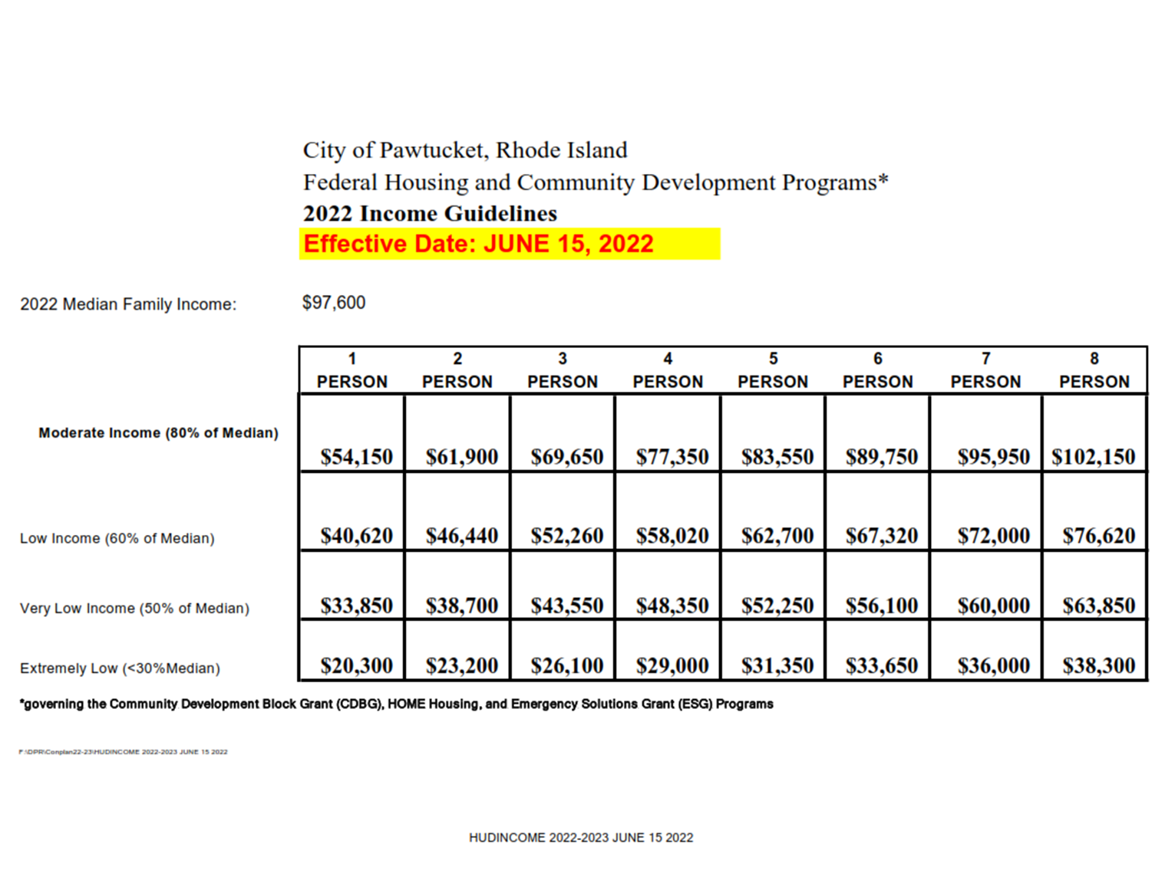

**Appendix B: Low/Moderate Income Designated Census Tracts**

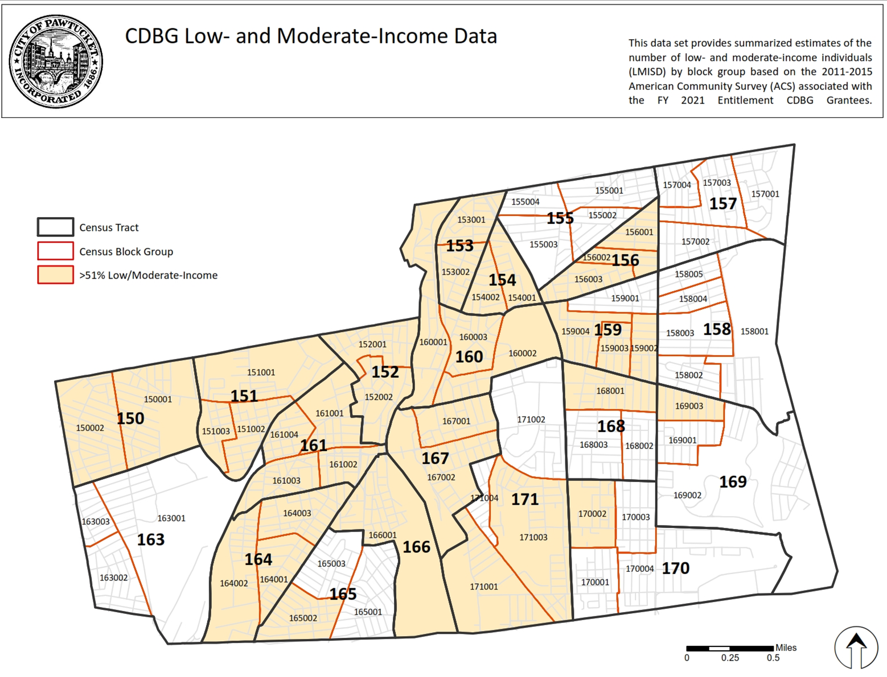

**Appendix C: Obtaining a Unique Entity ID (UEI) through SAM.GOV**

In order to be eligible to receive funding through this program and any future funding through the PBDC, a business **must obtain** a Unique Entity ID (UEI) through **SAM.GOV**. This process is free however may take several weeks from start to finish.

**In order to register for Unique Entity ID (UEI), please select the link below and follow the instructions:** [**https://sam.gov/content/entity-registration**](https://sam.gov/content/entity-registration)**.**

**Additional Guidance for obtaining an Unique Entity ID (UEI):**

* To see comprehensive instructions and checklist for entity registration, follow the link below:

<https://iae-prd-videos.s3.amazonaws.com/pdf/entity-checklist.pdf?X-Amz-Algorithm=AWS4-HMAC-SHA256&X-Amz-Date=20220714T061133Z&X-Amz-SignedHeaders=host&X-Amz-Expires=86399&X-Amz-Credential=AKIAY3LPYEEX3RP4EDU2%2F20220714%2Fus-east-1%2Fs3%2Faws4_request&X-Amz-Signature=2cdf2ebfb2235e9f38a2c670247bb22aa4f89b38588c885345bb832a5960eaa4>

* In order to check your registration status, please follow the link below:

<https://sam.gov/content/status-tracker>

* What do the different registration statuses mean?

<https://www.fsd.gov/gsafsd_sp?id=kb_article_view&sysparm_article=KB0029911&sys_kb_id=ae62cdca1b37c154c5c4dd39bc4bcb0d&spa=1>

* What's the difference between only getting a Unique Entity ID and registering your entity?

<https://www.fsd.gov/gsafsd_sp?id=kb_article_view&sysparm_article=KB0051214&sys_kb_id=dd40f4ef1b9641d0937fa64ce54bcb7a&spa=1>

* What should I do if my entity registration fails the IRS Consent validation?

<https://www.fsd.gov/gsafsd_sp?id=kb_article_view&sysparm_article=KB0016318&sys_kb_id=905be7631ba20d9406b09796bc4bcbdd&spa=1>